Lab: Configuring Rack Awareness

|  |  |
| --- | --- |
| **Objective:** | Configure a Hadoop cluster to be rack-aware. |
| **Successful Outcome:** | Each node in your cluster will be assigned to a rack. |
| **Before You Begin:** | SSH into hadoop-master. |

1. View the Current Rack Awareness
   1. Check out how many racks are being recognized by the cluster by running the fsck command:

$ su - hdfs

$ hdfs fsck –racks

Notice you only have one rack in your cluster:

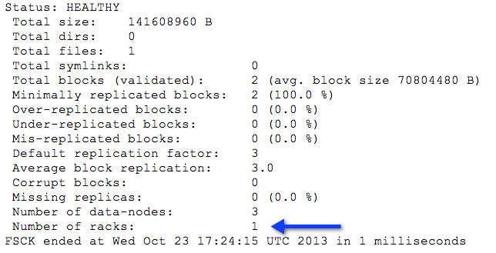

* 1. Switch back to the root user.

1. View the rack-topology Script
   1. On hadoop-master, change directories to ~/labs.
   2. View the contents of rack-topology.sh.sample, a sample rack topology script provided for you:

#!/bin/bash

ipaddr=$1

rack=`echo $ipaddr | cut -f1-3 -d '.' `

if [ -z "$rack" ] ; then

echo -n "/default-rack"

else

echo -n "/$rack"

fi

*NOTE: this script calculates the rack name using the IP address of the node. The first three parts of the IP address become its rack name. For example: if 192.168.1.100 is the IP address, then the rack name would be /192.168.1.*

1. Configure the Rack Script
   1. Copy the script to directory /etc/hadoop/conf as rack-topology.sh:

# cp rack-topology.sh.sample

/etc/hadoop/conf/rack-topology.sh

* 1. Edit core-site.xml and add the following properties:

<property>

<name>topology.script.file.name</name>

<value>/etc/hadoop/conf/rack-topology.sh</value>

</property>

<property>

<name>topology.script.number.args</name>

<value>1</value>

</property>

* 1. Distribute both rack-topology.sh and the modified core-site.xml file to all the nodes in the cluster:

# ~/scripts/distFile.sh rack-topology.sh /etc/hadoop/conf

# ~/scripts/distFile.sh core-site.xml /etc/hadoop/conf

* 1. Restart the NameNode so your changes to core-site.xml take effect:

# su -l hdfs -c "/usr/lib/hadoop/sbin/hadoop-daemon.sh stop namenode"

# su -l hdfs -c "/usr/lib/hadoop/sbin/hadoop-daemon.sh start namenode"

1. Verify the Rack Awareness
   1. Look in the NameNode log after starting the NameNode service. Identify the following lines by running the grep command:

# grep 'Adding' /var/log/hadoop/hdfs/hadoop-hdfs-namenode-hadoop-master.log

* 1. Notice the prior entries for “Adding a new node” used the default-rack, but now your nodes should each be in the appropriate rack from the rack-topology.sh script:

INFO net.NetworkTopology (NetworkTopology.java:add(413)) - Adding a new node: **/10.174.50**/10.174.50.60:50010

INFO net.NetworkTopology (NetworkTopology.java:add(413)) - Adding a new node: **/10.170.202**/10.170.202.246:50010

INFO net.NetworkTopology (NetworkTopology.java:add(413)) - Adding a new node: **/10.174.49**/10.174.49.252:50010

Notice the rack names are in bold in the output above.

* 1. Run the fsck command. You should see 3 racks now:

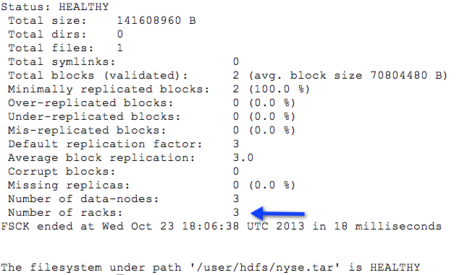

**RESULT**: The nodes in your cluster are now each assigned to a rack, and the rack assignment takes place automatically using the rack-topology.sh script. You can write your own custom script for automatically determining the appropriate rack names for your cluster nodes.